|  |  |  |  |  |
| --- | --- | --- | --- | --- |
| |  | | --- | |  | |  | |  | |  | |
| Luci  Human seeker robot in hostile environments |
| PROJECT SPRINT #7. DATE: 31th May 2022  Martí Caixal i Joniquet Ricard Lopez Olivares Hernán Capilla Urbano Bruno Moya Ruiz Marc Garrofé Urrutia |

Table of Contents

Project description 1

Electronic components 1

Hardware Scheme 2

Software Architecture 3

Amazing contributions 3

Extra components and 3D pieces 3

Foreseen risks and contingency plan 6

Algo 8

Updates Sprint 2 8

Updates Sprint 3 8

Updates Sprint 4 12

Luci

Human seeker robot in hostile environments

# Project description

*This robot’s aim is to seek people whose situation is not favorable in hostile environments. It searchs, avoids obstacles, detects humans in environments where people can’t afford to get in (such as gas, smoke, or buildings on fire) and notifies the emergency units.*

*“Luci keeps you safe, from environments where you won’t be safe.”*

# Electronic components

This is the list of the used components:

* *Raspberry Pi 3 B+*
* *Gravity: Gas sensor*
* *Ultrasound HC-SR04 distance sensor*
* *Arduino UNO Rev.3*
* *Motor Kit: DAGU 140rpm*
* *9V battery cable*
* *MLX90640 Thermal Camera Breakout*
* *Webcam C160*
* *Temperature/Humidity sensor*
* *Power Bank 5000*
* *L93B Quad Push*

# Hardware Scheme

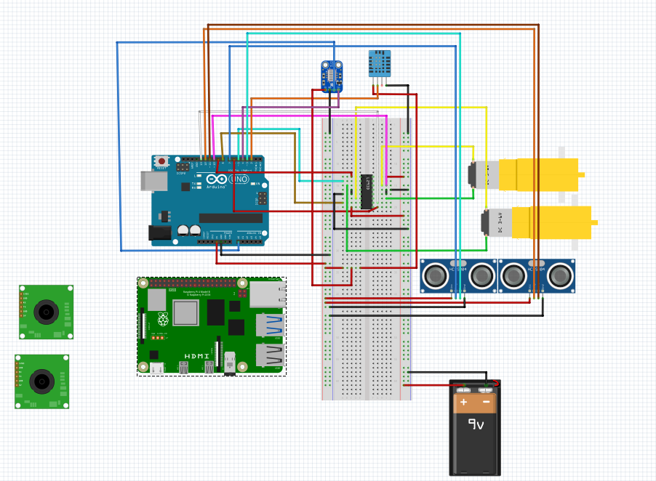

# Software Architecture

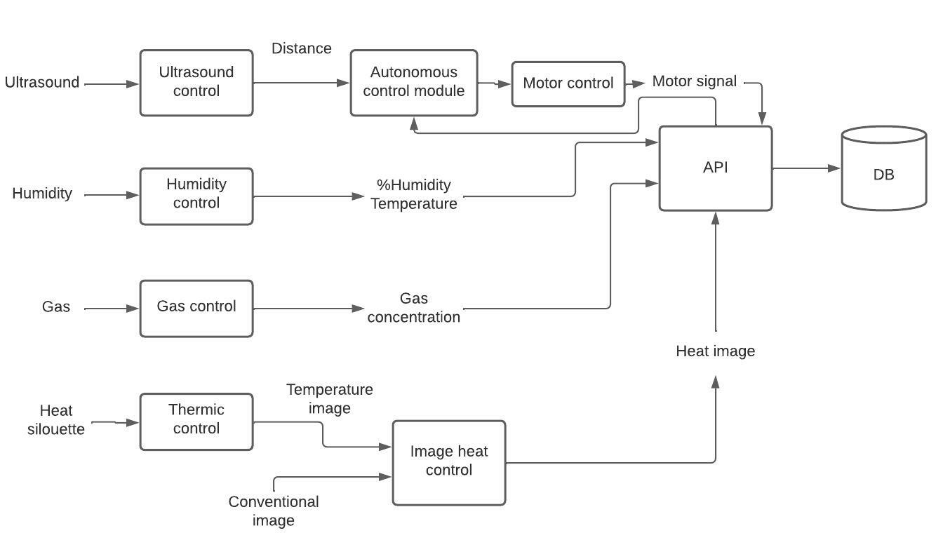

# Amazing contributions

*Mixing Compting Vision + Robotics with the purpose of analyzing normal images and thermic images to get the results.*

*Adaptive robot to different environments such as gas, fire, smoke, etc.*

*Not only detects but notifies.*

*Not only notifies but it also indicates the path that has followed the robot plus the obstacles that have found on its way.*

# Extra components and 3D pieces

* *Design 3 pieces*First we have the base of the robot. This one presents the part for puting the motors and wheels, also with all the essential elements like Arduino or Raspberry.
* Here we can see it empty: 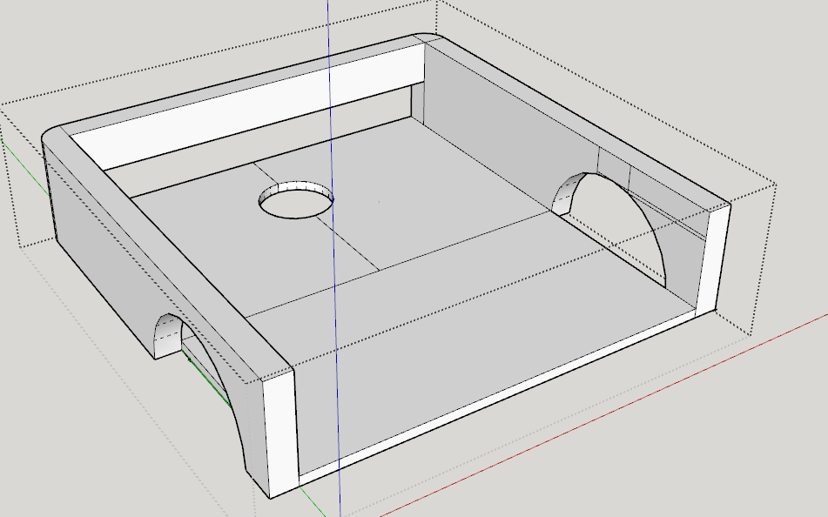
* The idea of ​​this rectangular format at the end (which is not definitive) is to install all the electronics and in this way to be able to connect the arduino to the computer with the cable, so with the batteries witouth having to take them off. The hole is currently very Big, once we have all the electronics we will try to 'measure' and so the cables do fit in perfectly without having a hole on the back.

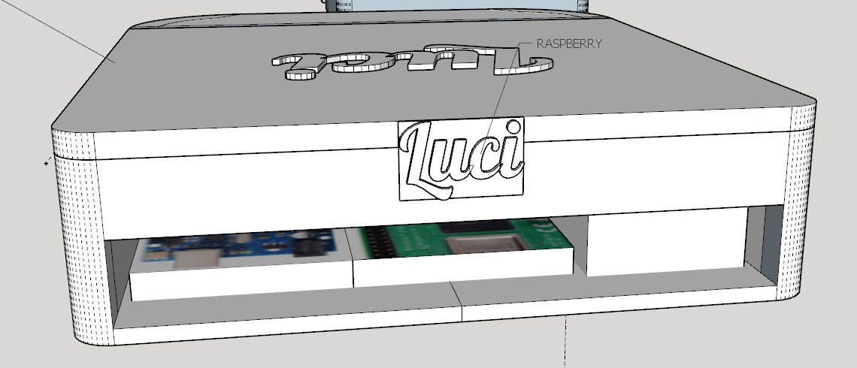

Next, we have the front part. Here it was necessary to chop the robot in parts due to the the fact that the idea is that everything can be printed on the 3D printer, but apart from that, it presents its benefits.

First of all, it is on where all the sensors and the cameras of the robot will be. Having it separately in a module allows the installation or customization of the module to remain effective without having to modify all the robot chassis. Once all the sensors are plugged in, their cables will go back to where the Arduino and raspberry are.

Attempts have been made to distribute all things so that the robot has a uniform weight around the entire structure, and that it is as small in height as possible so that it can enter more hostile places.

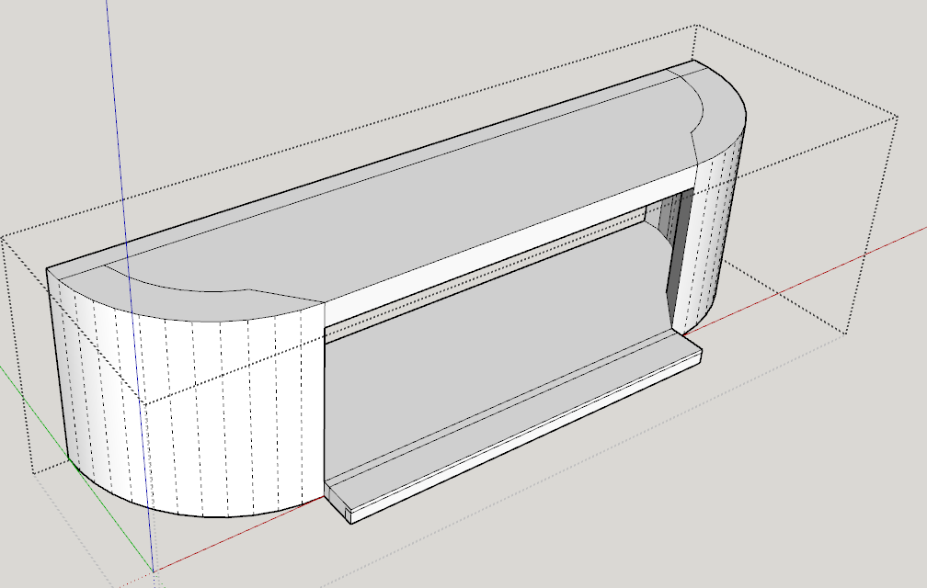

Finally, we have the cover, which allows us to close the whole system in a homogeneous structure and why not, beautiful, without all the electronics visible and protected at the same time.

The general idea of ​​everything was to make it a versatile and modular robot, to be able to tractor problems individually and also to fit everything in the printing base of a 3D printer.

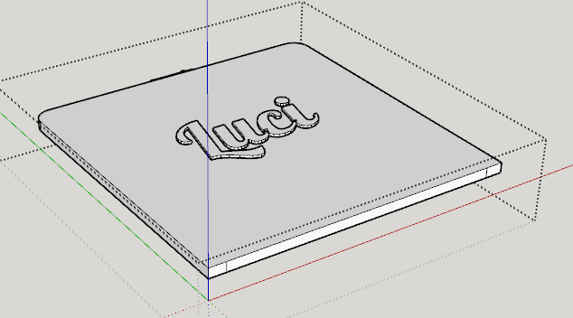

# Foreseen risks and contingency plan

|  |  |  |  |  |
| --- | --- | --- | --- | --- |
| **Risk #** | **Description** | **Probability** (High/Medium/Low) | **Impact** (High/Medium/Low**)** | **Contingency plan** |
| 1 | Camera not stable | Médium | Low | Stabilize the image sequence although the the FOV would be reduced |
| 2 | Faulty thermal camera | Low | Medium | Refund it and ask for a new camera if possible. Otherwise we would just use the default pi camera for computer vision |
| 3 | Cannot merge both images (normal and thermal camera) | Medium | Medium | Images would be needed to be treated separately. The predictions would likely be worse. |
| 4 | Wheels don’t move smoothly | Medium | Low | The robots would just not move smoothly. If it too much, some smoothing could be created by adding a chicken rubber around the wheels. |
| 5 | Not enough CPU/GPU power | Medium | Medium | Instead of getting the desired 20fps, we would have a lower fps and probably would not be able to use it in real time. |
| 6 | Not enough torque from the motors to move the robot | Low | High | More powerful motors would be required. Another option could be using extra gears to increase torque, but the speed would be decreased. |
| 7 | Don’t know how to connect Arduino and Raspbery pi together | High | Low | We would first try to do it on a PC with a simulator following some tutorials. Once we get to understand it, we would try to do it again now with the physical components. |
| 8 | 3D printed parts are not good or do not fit together with one another or the other electrical components | High | low | If the error is low, we could just file down the edges. Otherwise, some new parts would be to be printed. |

# Algo

* OpenCV Optical flow and key points detection in order to stabilizate the camera
* TensorFlow YOLO and SSD neuronal networks for person detection
* MPEG encoding for vídeo streaming

# Updates Sprint 2

* Motors now move in different directions. They go forward, backward, left, right (with the desired speed)
* All sensors working and getting correct input values
* We have python code that reads the sensors values from serial USB and then them them using websockets in real-time to the work in progress javascript-html frontend.
* This allows a communication between Arduino and python in real time, for example for controlling the robot motors from the frontend and whatever idea we want to implement. We can do it either in local or the internet with a free hosting.
* Along with this document, there is a video attached showing the motors move.

# Updates Sprint 3

* On the computer vision field, we are able to identify more than 40 objects using a SSD Deep Learning Net. Also, as a back-up System, we have a Histogram of Gradient Person detector.
* Also, we have developed an image stabilizer using our own module using point feature and homographs translations. As a back-up we have an open-source stabilizer that works better, but it has high latency (about 3 seconds).

As an example, here you can see a testing video (downloaded from Youtube) that we use to see how the stabilizer and the object detector works:

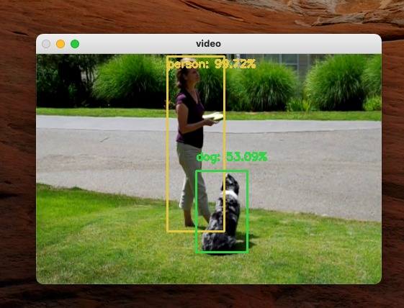

* Next, we have introduced the communication module between Luci's brain and the operator connected using a web browser. As shown, you can see a basic demonstration of the data coming from the robot's sensors. Thanks to the use of WebSockets (<https://socket.io/>) we can have this information in real time. This means we can also interact in real time from the dashboard with the raspberry, for example, for sending commands to the raspberry that consequently sends them to the Arduino. This will enable in future updates a control of the robot movement from the website UI.
* We have also added a redesign for it using Bootstrap framework, so it is a nice dashboard to look at, and data is easily available and readable from a human worker perspective:

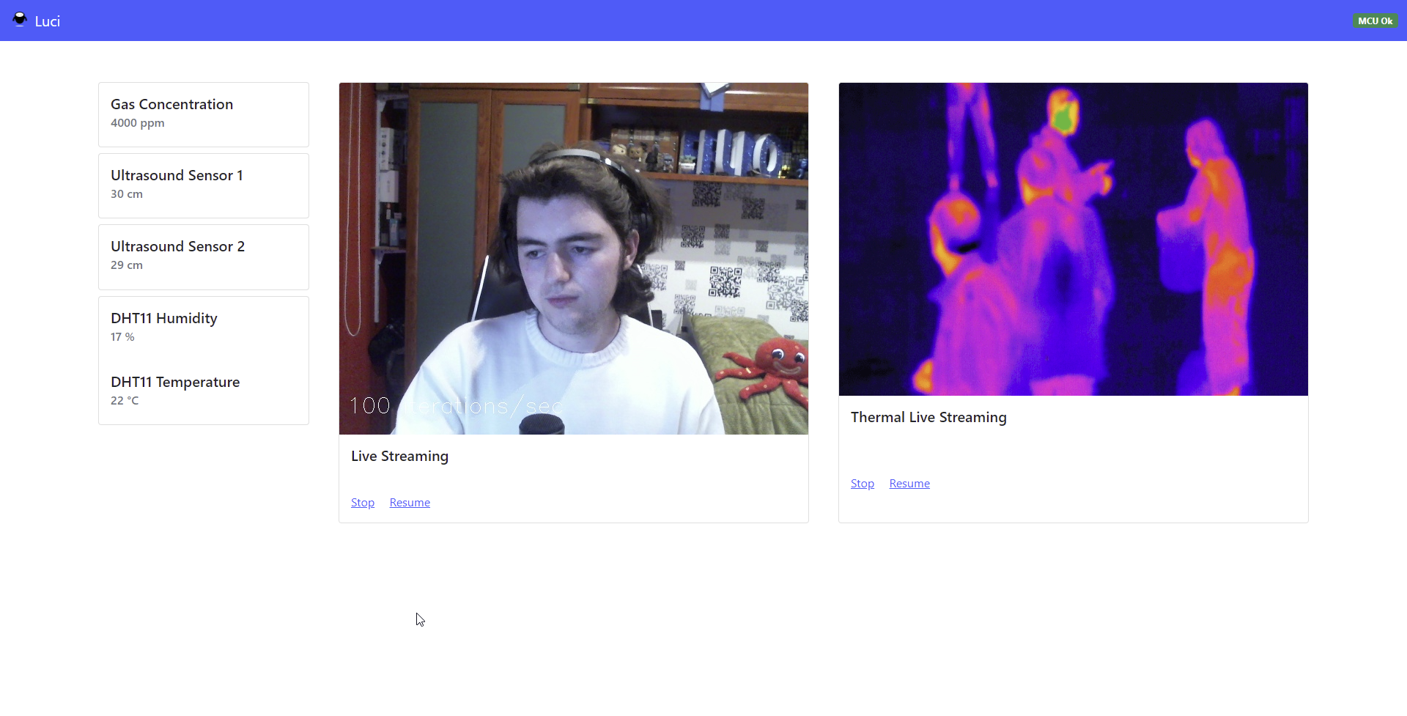

* Finally, you can see as well that now we also have a live streaming of the RGB Camera (Webcam). The live streaming of the thermal camera by the moment is a placeholder image, as of the time writing this sprint update, has not been given to us or either available on stock (: The catch here it uses threads, that allows us, without any processing of the image yet arrive to greater frames per second. Not only that, but once we connect the computer algorithms seen some lines ago with threads, will allow the raspberry cpu to separate each task on different cpu cores, and do some ‘balancing’
* 3D Wise, we have added some hinge on the cover so we can close and open, but if it adds much unnecessary difficulty to the print, we may remove it and attach the cover with some glue or whatever:

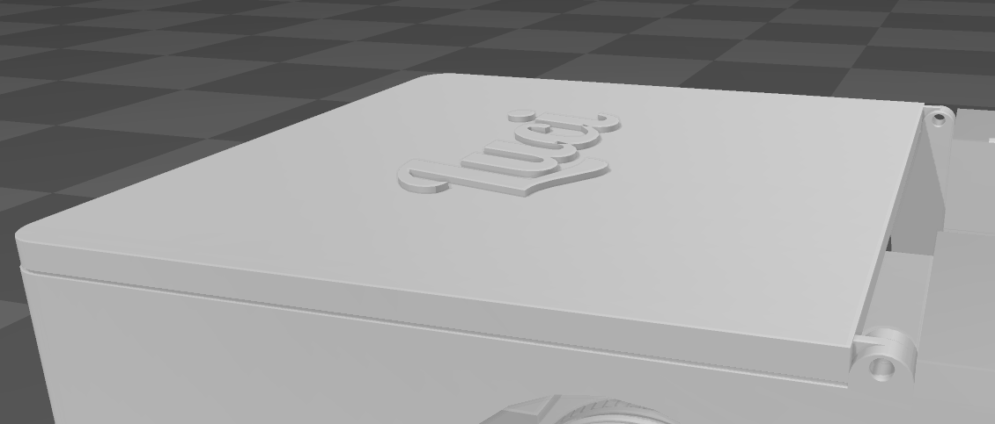

The sensors part has been redesign for a nicer design but we still are not 100% of it as some sensors may need to be attach with screws, and we prefer something that is easier to print and the sensors to attach:

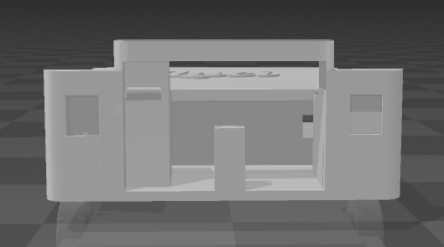

# Updates Sprint 4

During this week we have made tests with both cameras (pi noir and usb), how to connect them to the raspberry, how to read data, how to send both videos to the websocket we created and show it on the website.

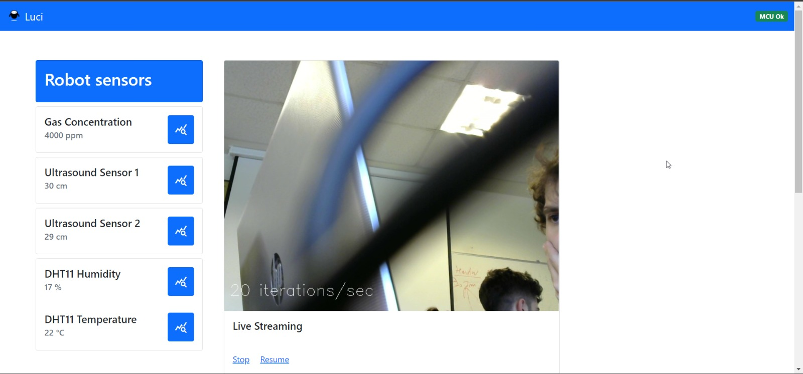

TODO’s :

1. Ricard - Merge camera image
2. Martí - Use the console gamepad to control the Robot
3. Bruno - 3D print and physically build the robot
4. Hernan - Apply to the raspberry the AI algorithm we created on Python to detect people.
5. Marc - Selft driving
6. Bruno – show voice recognition text on the web

# Updates Sprint 6

* During the final weeks, we've printed our robots using 3D printers and wood laser cutting machines in order to manufacture the base and the cover of Luci.
* As you can see, we have modified the main cover of Luci to increase temperature regulation and improve cable managing.

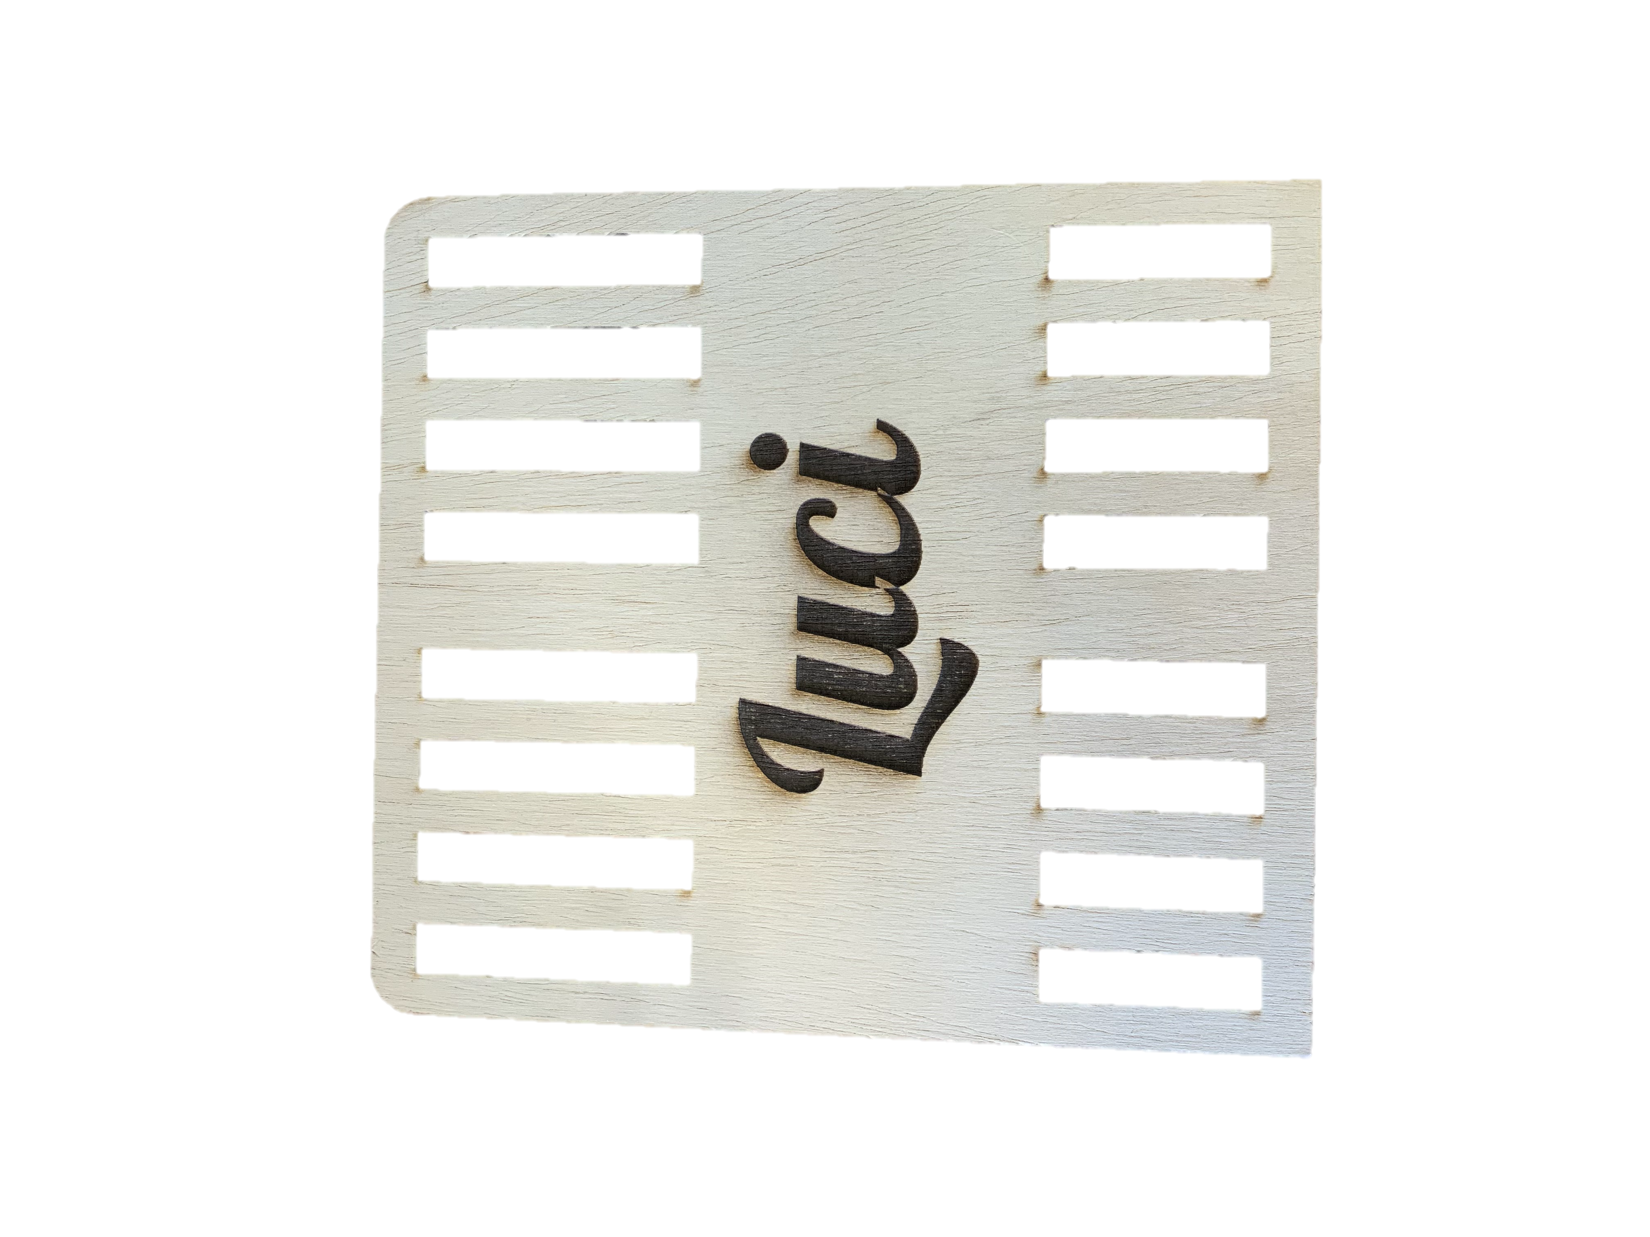

* On the software side, we have a fully working driving manual controller that works flawlessly using a gamepad controller.
* Despite of the transportation delays, we've received our thermal camera and our team has been able to get real time image from the device.
* In recent tests, we have found computer-performance issues while executing the person-detector neuronal network on the Raspberry Pi 4. In consequence, we tried our best to externalize the heaviest process to a laptop.
* During the externalization process, we have added more applications to plot the sensors data on the robot's live webpage.
* Fusion the image RGB(Logitech camera) and camera termic, the next picture is a prototype with simulated images.

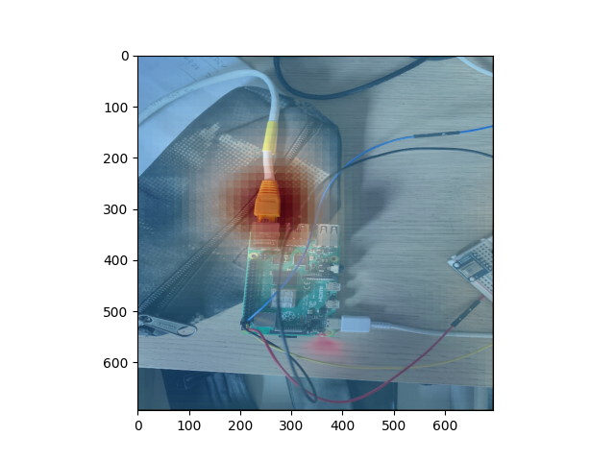

* Finish the hardware deployment and verify that all software component work correctly, for example: graphics sensors, manual driving, fusion images with termal camera and camera RGB, etc.
* Finish the sliders and presentation video.

References

This project has been inspired by the following Internet projects:

URL Link 1: <https://www.eltiempo.com/tecnosfera/novedades-tecnologia/firebot-el-robot-que-ayuda-a-prevenir-incendios-forestales-103122>

URL Link 2: <https://github.com/gritmind/image-processing-for-fire-detection>

URL Link 3: <https://makersportal.com/blog/2020/6/8/high-resolution-thermal-camera-with-raspberry-pi-and-mlx90640>